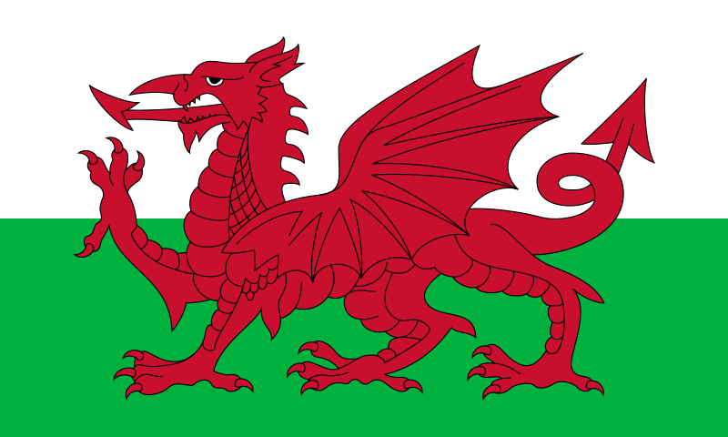
Eisteddfod 2025 Home Tasks

These tasks combine Welsh history, culture, creativity, and fun, and they offer a way for us to celebrate our Welsh heritage while being imaginative. Complete as many tasks as you like. Every entry will earn a house point.

1. Welsh Language Poetry
- Write a short poem in Welsh or about something Welsh (can be a mix of Welsh and English). It could be about the beauty of Wales, a Welsh legend, your favourite place in Wales or Welsh food.
Recite your poem and record yourself on Seesaw or Google Classroom for extra house points!

2. Create a Welsh Dragon Mask
- Using craft materials (paper, scissors, glue, paint, etc.), create a Welsh dragon mask. Once done, explain what the Welsh dragon represents and its significance in Welsh history.

3. Traditional Welsh Baking
- With the help of a parent or guardian, try baking a simple Welsh dish like Welsh cakes or bara brith. Bring into school for your bake to be judged.
Why not also write a step-by-step recipe for others to try at home?

4. Welsh Flag Scavenger Hunt
- Have a fun scavenger hunt around your home or garden, looking for things that are red, green, and white (the colours of the Welsh flag). Once you’ve found them, create a collage and take a photograph of your creation. Bring your photograph into school.

All entries to be brought into school on Tuesday 4th March to be judged.

