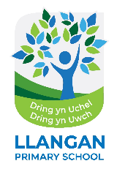
Ysgol Gynradd Llanganna Llangan Primary School

Headteacher: Mr James Griffiths
Llangan Primary School▪Cowbridge▪Vale of Glamorgan▪CF35 5DR▪Tel & Fax: 01446 772403
Email: llanganps@valeofglamorgan.gov.uk Website: www.llanganschool.org.uk
Twitter:@llanganprimary


Monday 18th September 2023

Year 4 Residential Urdd Sleepover Centre in Cardiff Bay.

Dear All at Home,
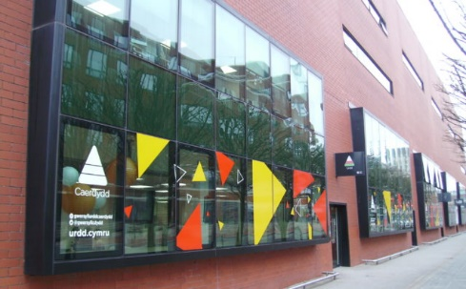
We’re thrilled to be able to confirm we have booked a Year 4 Residential Trip this year. We have selected the Urdd Sleepover Centre in Cardiff Bay for one night on 16th-17th November and have joined with Llansannor and Llanharry CIW Primary School to share the fun! The centre offers and organises wonderful activities for the children to have a fun-filled, action-packed time around Cardiff and we think this will be a perfect introduction to being away from home. We’re confident we have selected a range of activities that will suit all our learners and offer them some fabulous opportunities to share with their friends and make new ones from a local primary school.

Our itinerary is currently being confirmed but we will be taking part in the following activities during our time at the Centre:

- High ropes at Cardiff International White Water, Cardiff Bay
- Ice skating at Vindico Arena, Cardiff Bay
- Water Taxi Ride
- Ten Pin Bowling at Hollywood Bowl, Red Dragon Centre, Cardiff Bay
- Tour of BBC studios, BBC CYMRU WALES, Central Square, Cardiff Central
- Tour of Principality Stadium, Cardiff
More information about the Urdd Centre can be found: https://www.urdd.cymru/en/residential-centres/cardiff/

The cost per child is £120, which includes travel, accommodation, dinner, breakfast and a packed lunch as well as any charges linked to the attached itinerary.

If you would like your child to attend the trip, please can we ask you to complete the permission on Parent Pay along with the payment of £50 by the 30th of September, with full payment required before the stay. Please contact the school if you wish to alter your ParentPay settings to reflect this date. We really want all our children to experience this residential and will do all we can to support any families that may need financial help at this time. Please contact Mrs Hale to discuss this further 01443772403 or email LlanganPS@valeofglamorgan.gov.uk

If you have any questions, please don’t hesitate to contact us at school.

Yours Sincerely,

Mr Griffiths
(Headteacher)

