Friday 11th September
Due date: Wednesday 23rd October
This week, we would like you to create a weather chart for 7 days using the language skills you have learnt in your Welsh lessons.
The question we have been looking at is:
Sut mae’r tywydd heddiw?
How is the weather today?

Below are some sentence structures to help you with your weather chart. They get progressively more challenging so you can choose how much challenge you would like to include in your chart. Please be creative with your weather chart and include pictures!

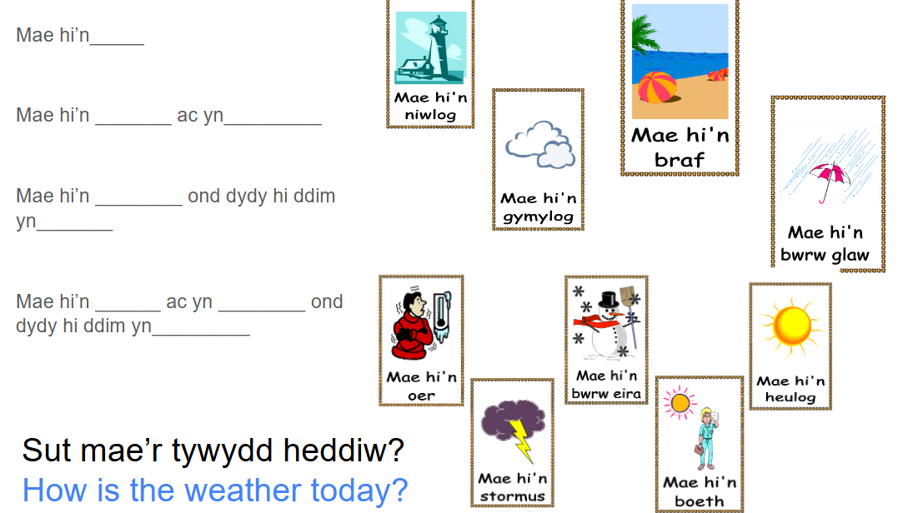

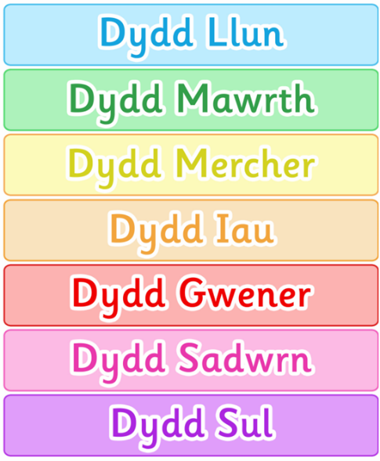
Why don’t you challenge yourself and write the days of week in Welsh as well!
Any questions, please don’t hesitate to ask.
Many thanks,
Miss Spiller and Mrs Jarman-Davies

