Our Cynefin Topic Jump Out Blog

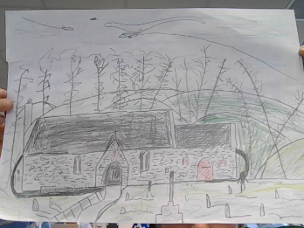
As our cynefin topic has come to a close, in this blog we will tell you all about what happened on this journey.
So at the start of the journey, we did quite a lot of artwork like this St. Canna’s church piece of artwork. Later in this journey there will be even more artwork. We wrote paragraphs about our favourite cynefin places like most of the boys say skate park and girl say something like there house also. We had to choose a place in your cynefin to draw like the school and their house. Most boys drew the skate park, and most girls drew the school.
So that was our cynefin topic.

By Ashley Chidgey.

