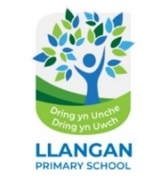

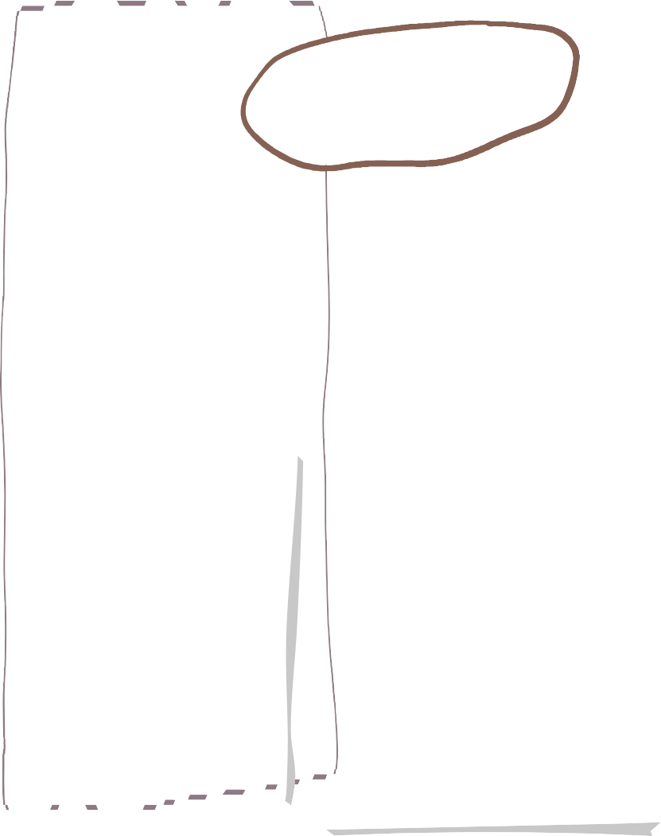




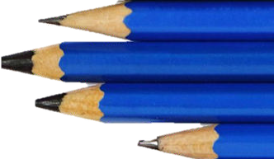

Plaza 3 - Autumn Learning Overview

Science & Technology
Maths
LLC- English

- Narratives
- Explanations
- Recounts
- Information
- Non – chronological reports
- Newspaper reports
- Letters of protest
- Diary
- Writing a script for a website
- Writing speeches for or against using children in mines
- Creating encyclopedia entries

We are reading…

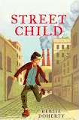

Place value – ordering, comparing, rounding and partitioning numbers to 1 million. and beyond.
Addition and subtraction – mental strategies and multi-step problems.
Multiplication and division – multiplying by 10, 100, 1000.
Common factors

In Science this term we will be exploring and investigating:

- Materials and changes
- Materials and properties
- States of matter

French
All about me

We will be using descriptive language to describe ourselves, likes, dislikes and hobbies.
- Looking at the art work of Robert Morgan .
- Exploring miners’ portraits.
- Exploring ‘industrial art’ Lowry etc.
- Charcoal and chalk as media.
- Collecting and using digital images.
Expressive Arts

During our computing lessons this term we will learn to work together to plan, create and refine an online collaborative document.
We will then apply these skills to create our own website about life in Industrial Wales.
Computing
Health & Wellbeing
Humanities
Within our inquiry pupils will have the opportunity to understand that human societies are complex and diverse and shaped by human actions and beliefs.

Through exploration of childen’s rights, historical facts and debate they will become informed, self-aware citizens with the challenges and opportunities that face humanity and are able to take considered and ethical action.
In PE and games this term we will be focusing on playing a range of invasion games.

We will develop and refine ball skills and movements such as travelling, dodging, swerving and tackling, whilst providing opportunities for developing team work, perseverance and resilience.

Inquiry Overview

In Welsh this term we will be focusing on revising previous language patterns, talking about activities, hobbies and weather.

We will be learning new vocabulary and sentence patterns using present, future and past tense.
LLC - Cymraeg
Our inquiry question this term is ‘How was life for a child in Industrial Wales?
During this inquiry pupils will explore the history of coal mining, strikes and their effects on the miners, families and communities, the legacy and future of coal mining, how and why children worked in mines and factories , the rights of children and how industry has changed in Wales.




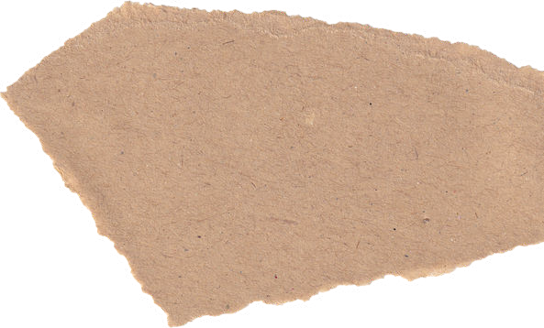



- Daily reading
- Learning Logs
- Mathletics
- Ed Shed
- Weekly spelling
Home Learning

