Literacy Homework

People Who Changed the World – Aneurin Bevan
This week we have been learning about Aneurin Bevan and how he helped to create the NHS. We have also been thinking about the important jobs that doctors and nurses do to help people.
Look carefully at the picture below. Think about:
- Who can you see?
- What are they doing?
- How might they be feeling?
- What might they be saying?
- How are the doctors and nurses helping?

⭐ 1 STAR – Simple Sentences

⭐⭐ 2 STARS – Extended Sentences
Your job is to write 5 extended sentences about the picture.
An extended sentence gives us more information. You can join ideas together using a conjunction.

Conjunctions are joining words.
Try using:
and – adds another idea
because – gives a reason
but – shows a difference
so – tells us what happened next
when – tells us when something happened
while – tells us what was happening at the same time

⭐⭐⭐ 3 STARS – Super Challenge!
Your job is to write a short paragraph of 6–8 sentences about the picture.
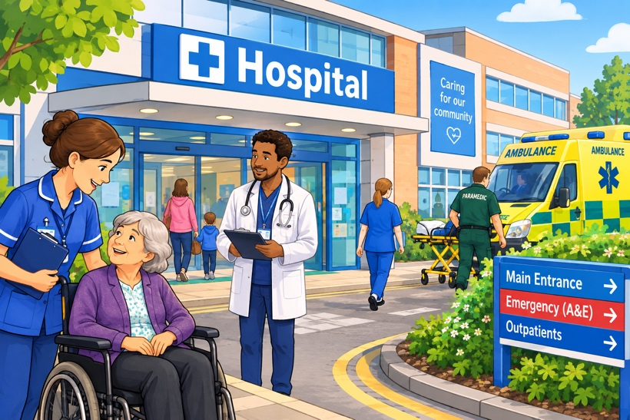
Try to include:
⭐ Interesting adjectives
⭐ Extended sentences
⭐ At least 3 different conjunctions
⭐ What the people are doing
⭐ How the patient might be feeling
⭐ Why doctors and nurses are important

