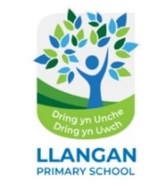

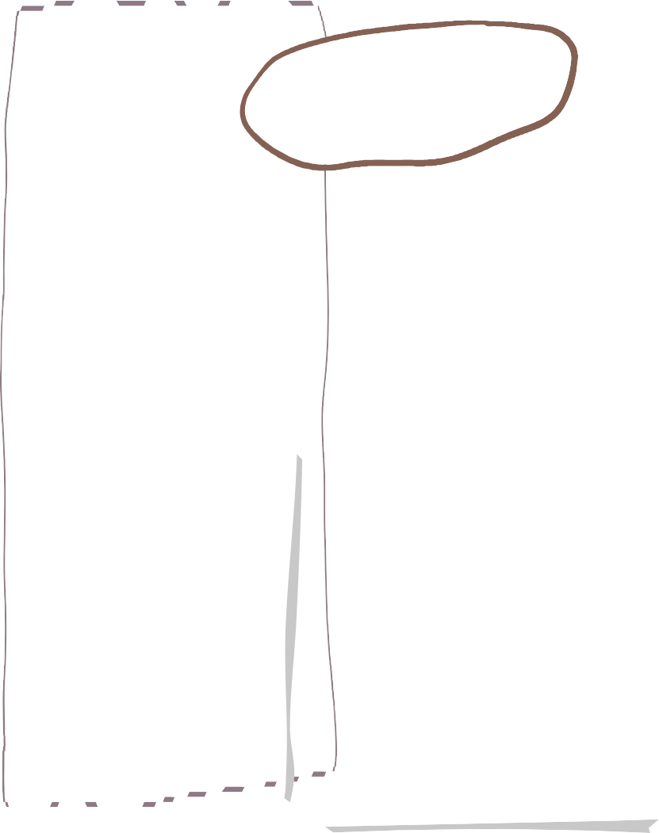


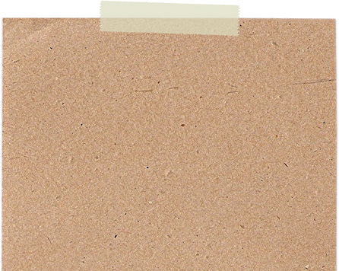

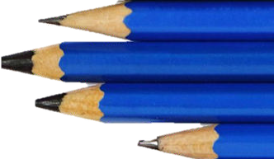

Pili Pala - Autumn Learning Overview

Science & Technology
Maths
LLC- English

* Narratives
* Story Sequencing and retelling stories
* Reading traditional tales
* Writing instructions.
* Hear and retell stories about growing up and life in the past.
* Sequence events using first, next, then and finally.
* Write captions, labels and simple sentences for then-and-now photographs.
* Recount our school trip

We will be focusing on the following skills
*Learning our phonices using Read, Write, Inc
*Learning to read and spell our RWI words
*Mark Making
*Handwriting – developing our pencil grip
*Correct letter formation.

We are reading…

- Use daily routines, birthdays and seasons to explore time and order.
- Sequence photographs and events; use before, after, earlier and later.
- Compare and measure height, length and capacity as things grow or change.
- Collect and represent class data about toys and transport.
Notice patterns; use positional and ordinal language.
- Observe how people, plants and materials change over time.
- Name body parts and describe how our needs and abilities change as we grow.
- Explore materials in old and modern objects and why materials are chosen.
- Investigate pushes, pulls, wheels and axles through toys.
Design and improve a moving toy or future object.

French
- Different French songs
- Simple phrases
- Words linked to our inquiry.
- Create self-portraits showing ourselves as babies, now and in the future.
- Explore old photographs through drawing, collage, print and role-play.
- Learn traditional Welsh and English rhymes, songs and playground games.
- Use music and movement to represent growth and transformation.

Expressive Arts

Computing
Health & Wellbeing
Humanities
- Direct a Beebot around different scenes.
- Take photographs safely with adult support
and discuss consent.
- Sequence images to create a simple digital
timeline or narrated tour.
- Recognise that digital images and
messages can be saved for the future.
- Use photographs, artefacts, maps and stories as clues about the past.

- Compare childhood, homes, school, toys and transport then and now.

- Order events and recognise change and continuity in our own lives.

- Explore the local area and a Welsh heritage setting as change detectives.
Recognise that people may remember the past differently.
In PE and games this term we will be focusing on ball skills. PE will be on a Friday.
We will also be learning to:
- Celebrate growing, changing abilities and individual differences.
- Recognise feelings linked to change and identify trusted adults who help us.
- Develop cooperation through partner talk, traditional games and team tasks.
- Talk sensitively about diverse families and traditions.

Inquiry Overview

In welsh we will be learning
• simple phrases linked to our
inquiry.

• Key phrases in our helpwr
heddiw slots
Pwy wyt ti?
Sut wyt ti?
Pa lliw?
Children will investigate change through their own lives, toys, homes, school, transport and the local community. They will use photographs, objects, stories, oral history and visits as evidence, place examples in time order, explain what has changed or stayed the same, and imagine what might change next.
LLC - Cymraeg

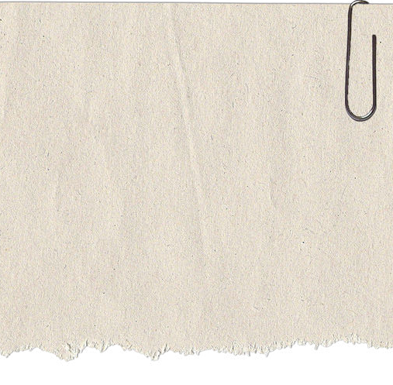

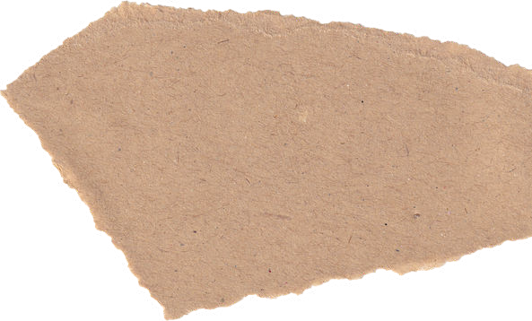



- Daily reading
- Learning Logs
- Mathletics

Share a baby photograph on Seesaw
Home Learning

