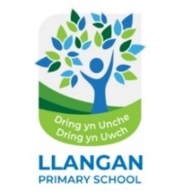

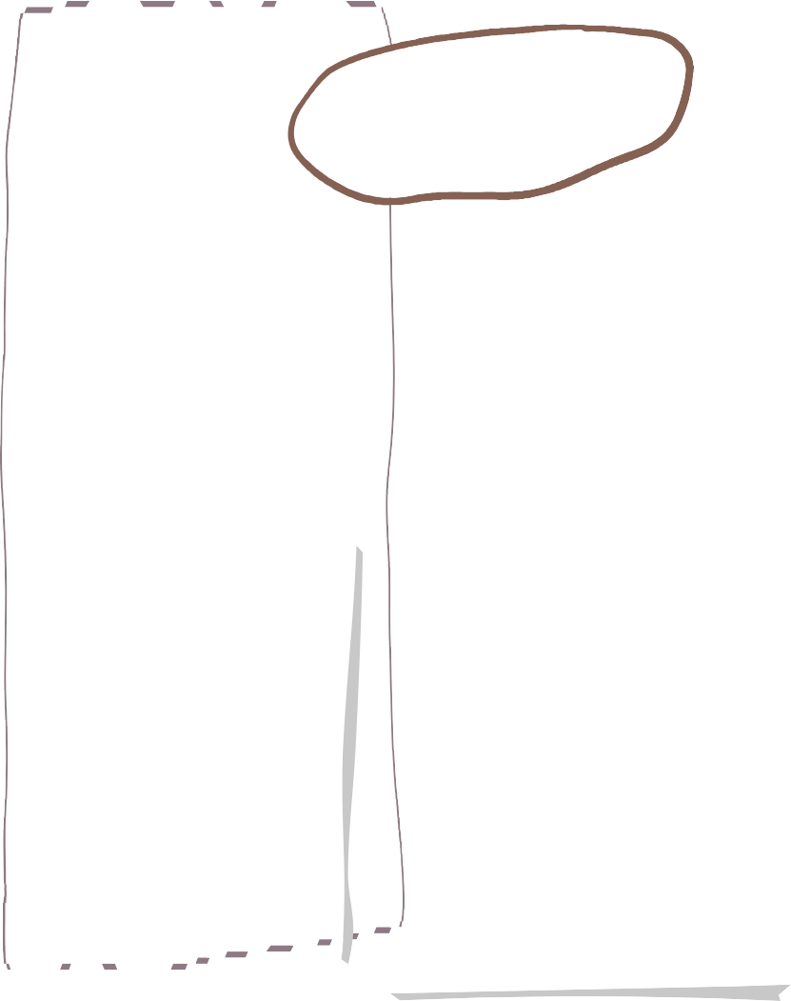




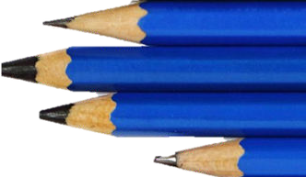

Plaza 3 - Autumn Learning Overview

Science & Technology
Maths
LLC- English

- Narratives
- Explanations
- Recounts
- Non-chronological information reports
- Newspaper reports
- Letters of protest
- Diary entries
- Writing a script for a Digital Tour
- Writing speeches for or against using children in labour

We are reading…

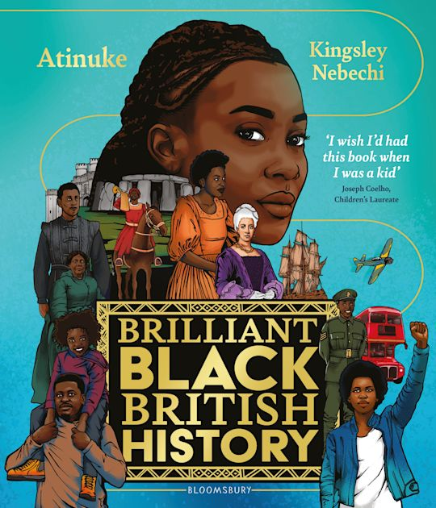

- • Investigating gears, pulleys, levers, and cogs to understand how steam engines and pithead winding gear operated during the Industrial Revolution.
- • Exploring friction, gravity, and mechanical advantage in mining transport systems.
- • Examining states of matter and water-to-steam thermal expansion that powered Victorian industry.

- Fractions: Simplifying fractions, finding common denominators, comparing and ordering fractions, and calculating fractions of amounts (
- Decimals & Percentages: Understanding value up to three decimal places, converting between fractions and decimals, and calculating percentage increases in population and coal output.
- Four Operations with Decimals: Multiplying and dividing decimals by 10, 100, and 1000, and applying formal written methods to multi-step financial word problems.

French
- All about me

- We will be using descriptive language to describe ourselves, likes, dislikes and hobbies.
- Featured Artist: Exploring the industrial paintings and prints of Valerie Ganz (celebrated Welsh artist known for depicting pithead landscapes, underground miners, and South Wales mining communities).
- Exploring miners' portraits and dramatic contrast in industrial artwork.
- Using charcoal, chalk, and graphite as media to capture heavy texture and light.
- Collecting, editing, and composing digital images of industrial heritage sites.

Expressive Arts

Computing
Health & Wellbeing
Humanities
- Understanding how human societies are complex, diverse, and shaped by human actions and beliefs.
- Exploring children's rights, historical facts, and ethical debates regarding child labour, working conditions, and community changes in Industrial Wales

- Digital Communication & Design: Learning how data and media are communicated across digital platforms.
- Designing user-friendly web layouts, selecting effective typography, and managing collaborative digital content to build a published website about life in Industrial Wales.

In PE and games this term we will be focusing on playing a range of invasion games.

We will develop and refine ball skills and movements such as travelling, dodging, swerving and tackling, whilst providing opportunities for developing team work, perseverance and resilience.

Inquiry Overview

Within our inquiry, pupils will explore the history of coal mining, strikes, and their effects on miners, families, and communities. They will examine the legacy and future of coal mining, how and why children worked in mines and factories, the rights of children, and how industry has changed in Wales. Pupils will have the opportunity to understand that human societies are complex, diverse, and shaped by human actions and beliefs. Through exploration of children's rights, historical facts, and debate, they will become informed, self-aware citizens equipped to take considered and ethical action.
- Focusing on revising previous language patterns, talking about activities, hobbies, and weather.
- Learning new vocabulary and sentence patterns using present, future, and past tenses

LLC - Cymraeg



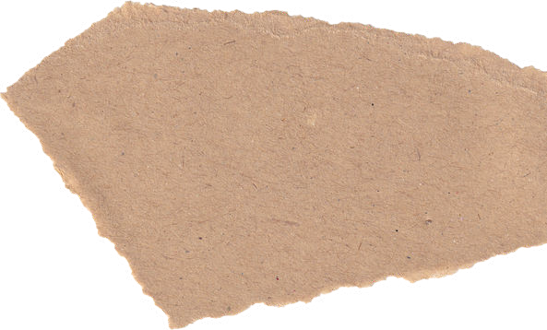



- Daily reading
- Learning Logs
- Mathletics
- Ed Shed
- Giglets
- Weekly spelling
Home Learning

