Converting Measurements

Learning Objective: To convert between measurements including the use of decimal numbers.
Task 1: Complete the table to convert the measurements in each row.
 | Cm to mm  (x10) | M to cm  (x100) | Km to m  (x1000)
1 | 10 mm | 100 cm | 1000 m
3
7
2.5

Task 2: Convert and order the measurements from smallest to biggest in grams.
1 kg | 6 kg | 5.5 kg | 3000 g

Smallest |  |  | Biggest

Task 3: Tina is making a fruit drink in a large bowl with the capacity of 9000 millilitres. Measure the 3 jugs below and change all the measurements to millilitres. Will all the liquids in the jugs below fit into Tina’s fruit drink bowl?
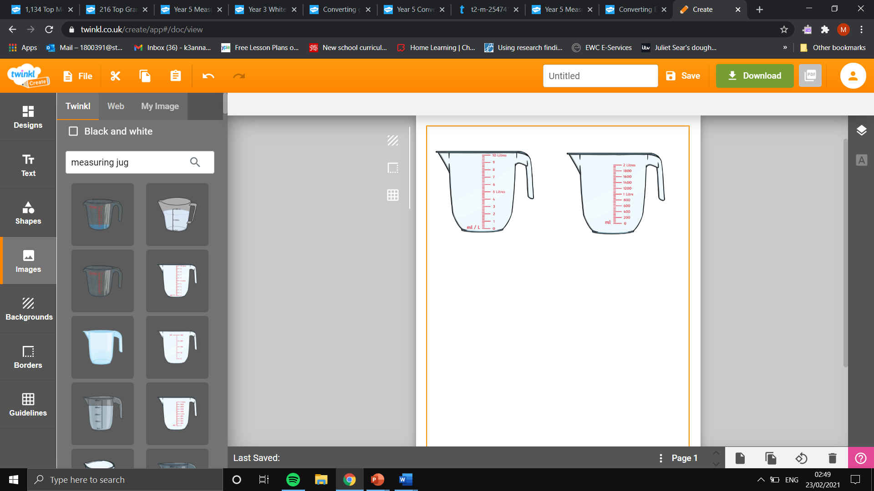
Total measurement in litres=

Total measurement in millilitres=

Will the liquids fit into the fruit drink bowl?

Measurement in Litres=
Measurement in Millilitres=
Measurement in Litres=
Measurement in Millilitres=
Measurement in Litres=
Measurement in Millilitres=

